Notes on using the Mountfield SP46 Elite lawnmower

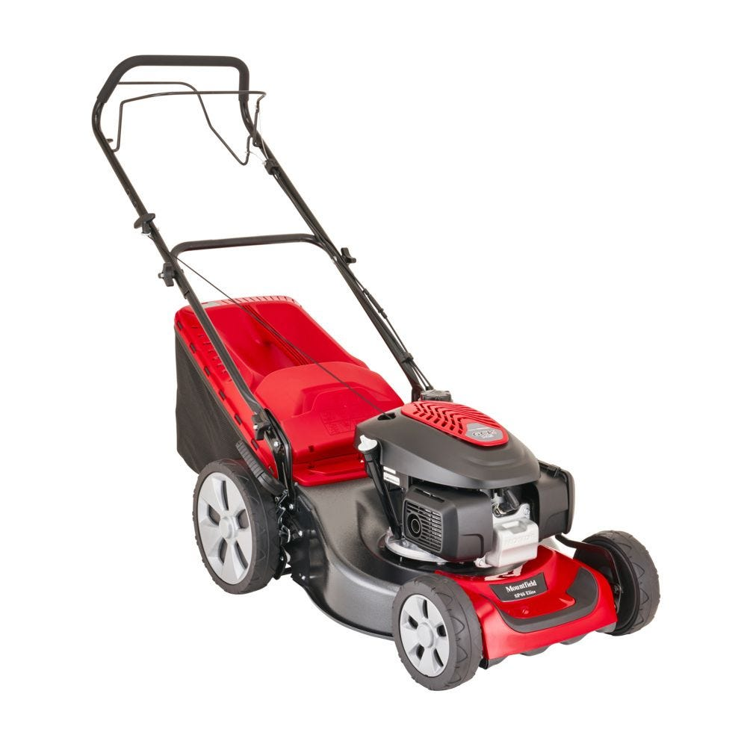
The DGA is now the proud owner of a brand new that will live in the main equipment container with the other bits of shared equipment we have.
We've opted for a very robust model that's got an easy-start "auto-choke" petrol engine (Honda) and large rear wheels that cope better on uneven ground. It's also self-propelled, with driven rear wheels to make mowing with it that bit easier (especially uphill!).
We want everyone to feel safe and confident in using this new mower in a way that helps us keep it in tip-top condition, so please can you read the following notes before using it.
Notes:
- Please take the mower in and out of the container with care not to catch the cutting blade on the front edge of the container.

2) It should need no "mechanical attention" when starting the mower, just follow these simple points please:
- The mower should be outside the container on a flat surface without obstacles or high grass.
- Please check it has sufficient fuel in the tank (we'll check the oil on a regular basis, so you don't have to).
- The light grey fuel tap on the left-hand side of the engine should be set to its open position (horizontal - as shown on the sticker above it).
- Fully engage the throttle handle (the rail in front of the handlebar) then take up the slack in the pull-cord and pull briskly in the direction of the cord itself.
- Once the mower is running, engage the second wire handle (between you and the handlebar) to engage the drive to the rear wheels.
3) Please try to avoid mowing in wet conditions.
4) Always use the grass collection container that comes with the machine when mowing. This has a light grey indicator that will pop up to let you know when it’s full and needs emptying.
5) Please can you have a thorough look at the area you're about to mow before you actually start mowing. It's really important to remove any obstacles like rocks, boards or bits of wood etc. that may damage the cutting blade.
6) This mower has 6 cutting height positions and a single adjustment handle (close the to rear wheel on the right-hand side) that will adjust all 4 wheels in one go.
Please can you make sure that the cutting height you're using is appropriate for the length of grass in the area you are cutting. The mower has a very competent petrol engine but the very maximum length of grass you should attempt to cut (with the mower in its highest cut position) is 9cm - this is about the same length as the height of a typical playing card. Anything longer than this should be cut back using a strimmer, not a lawnmower. Forcing to engine to do more than it's designed to is a very common way that mowers get damaged.
7) Please can you ensure that you give this mower a thorough clean when it's returned to the container (new brushes will be provided). But please don’t tip the mower on its side when you do this, tip it forward instead please, being very careful not to damage the front of the mower.
8) Please refrain from making any mechanical adjustments, this mower is covered by a 5-year warranty, so in the unlikely event that we have any issues, they need to dealt with by an approved Service Center (Celtic Mowers in Swansea) so just drop me an email to let me know what issues you've had straight away please.

